1. Turing Machine (TM) tape head can move in left, right, up or down direction in
   1. Multi-tape TM

ii. Multi-head TM

iii. Multi-track TM

iv. Multi-dimensional TM

1. A: The Machine Halts when there is no possible transition to follow

B: The TM final state has an outgoing transition

Which of the following is true ?

A and B are true

A and B are false

A is true and B is false

A is false and B is true

1. Generate the accepting language L for the given scenario. Jay vists a store to buy some gallon of milk and bread. First she buys milk followed by bread, which is twice the quantity of milk. Design a TM for the generated language
2. Draw a transition diagram and Transition table of the constructed TM
3. Is it a Computing device or an acceptor. Justify the answer

Simulate a TM for MilkMilkBreadBreadBread

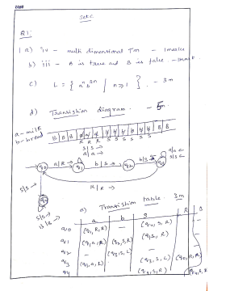

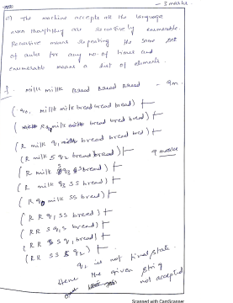

An UPI based online payment application wishes to attract new customers. In this perspective, it has decided to give a reward of Rs 5 for every transaction made to the sender as well as the receiver of the amount.

1. The Turing machines are brain child of __________

i) **Programming languages**

ii) Microprocessors

iii) Stored program concept

iv) Microcontrollers

1. If MPCP can be solved then PCP can also be solved. Which property illustrates this?

i) Computational complexity

ii) **Decidability**

iii) Reducibility

iv) Computability

1. Construct a TM transition rules that calculates the total amount of the receiver (including reward).

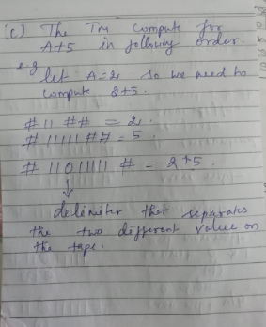

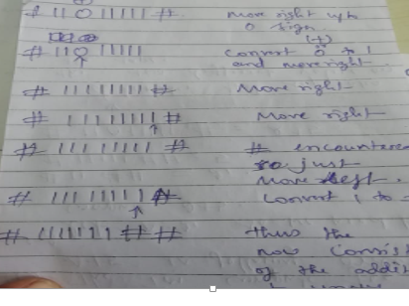

1. Draw the transition diagram and table for the same

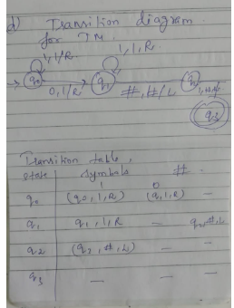

1. Compute the total amount at the receiver if the actual transaction is Rs 6. Illustrate it using instantaneous description

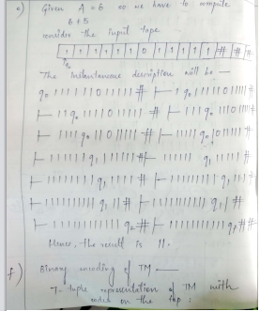

Encode the constructed TM in binary language and then decode them. (6 marks)

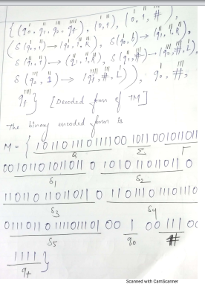

Every year a common festival is celebrated between two villages A and B. On an account of this, a local sport is organized by the villagers. The selection of players in this year happens according to the given table (Here 0 indicates women and 1 indicates men). The positioning of the players is made in such a way that at any particular position, if village A places a set of players from set i, then village B should also place the set of players from set I only. This pattern will repeat for other sets also.

|  |  |  |
| --- | --- | --- |
| **i** | **A** | **B** |
| 1 | 11 | 10110 |
| 2 | 111 | 000 |
| 3 | 001 | 0101 |
| 4 | 010 | 0 |

1. Consider the statements:

S1: All recursively enumerable languages are countable.

S2:Set of all non-regular languages over the alphabet {a,b,c} is recursively enumerable.

i) **Both are true**

ii) Only S1 is true

iii) Only S2 is true

iv) Both are false

1. A NP complete problem is the conjunction of_________

i) NP hard and NP

ii) NP and P

iii) NP hard and P

iv) NP hard alone

1. An audience claims that there are atleast two ways in which the men and women of villages A and B can be placed after fulfilling the condition of the game. Is this true? If yes, give the sequence.
2. Assuming the above given table is a MPCP problem, convert it into PCP.
3. Construct a TM, for another game in which if village A places men then village B should place woman and vice versa. Design a TM to help village B in doing so.

Find the arrangement of village B if the village A places players in the following order: “men, women, women, men”.